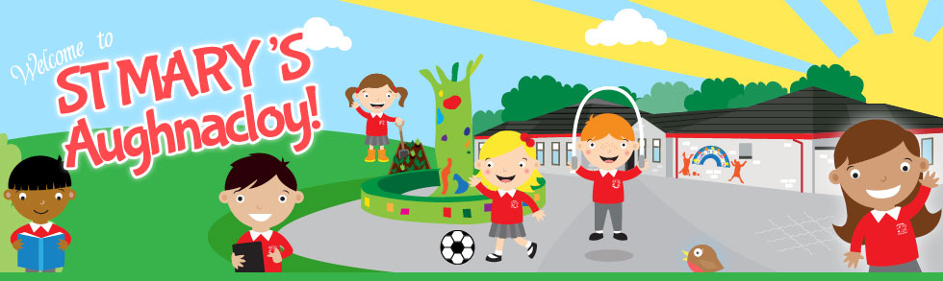

Saint Mary’s Primary School

Pastoral Care Policy

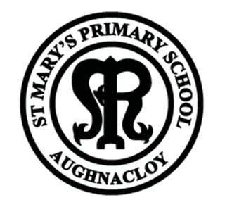

Updated: May 2015
Reviewed: May 2018

ST. MARY’S PRIMARY SCHOOL

PASTORAL CARE POLICY

Introduction

The Principal and Staff of St. Mary’s firmly believe that as well as educating our pupils in the areas of academics, we share a deep concern for each child’s personal and social development: that is, our approach will include the essential elements of the children’s safety, security and personal welfare.

After full staff consultation, we have decided to implement a pastoral care policy through the main areas of: School Ethos - Provision - Management.

School Ethos

We place a strong emphasis on our school’s physical environment. We strive to create a warm, inviting, friendly atmosphere with evidence of children’s successes displayed throughout the school. Classrooms will be bright and cheerful and conducive to effective learning. This atmosphere will allow pupils to be:
- Happy
- Safe
- Valued for themselves as individuals
- Supported
- Encouraged to voice any concerns they may have
- Valued for their contribution to the efficient and effective running of the school

To create this atmosphere, we are further aware of the vital part played by “relationships” between pupils, teachers, teachers and pupils, teachers and parents, teachers and Principal and indeed between all personnel who are involved in the daily life of the school.

The Principal will continue to acknowledge the dedication and professionalism of the teaching staff. She will endeavour to make working conditions as comfortable and pleasant as possible and both welcome and value their contributions and opinions on all aspects of day-to-day affairs; as well as on producing policy documents and guidelines as required.

Pupils will be encouraged to work together harmoniously in classroom activities: they will be motivated, through good example and self esteem, to have respect for each other at all times in school and at home. In the playground they will be encouraged to have a sense of “fair play,” a concern for each other’s welfare and safety and a caring approach to younger children. For this reason, the pupils of different age groups have been assigned certain areas of the playground: this is to encourage “peer” relationships and to minimise the potential for accidents!

In the area of academics, the school has valued the support of the assigned Educational Psychologist. Lines of communication have been - and will be - open to the local Branch of the Social Services (Dungannon).

The pupils in Key Stages 1 and 2 have had the benefit of a programme of Fire Prevention. Additionally, the children in key Stage 2 benefit from a visitor who gives specific advice on drugs and alcohol abuse.

The teaching staff strive to administer fairly the aspects of our Discipline Policy. Staff are encouraged to be consistently fair and strong emphasis on promoting positive behaviour is adhered to. A balanced approach in applying sanctions for unwelcome behaviour has been agreed and carried out. At our weekly assembly, various aspects relating to discipline and the children’s welfare in general are emphasised e.g. safety in movement in/around the school, courtesy to teachers and to each other, an orderly manner for waiting on/boarding transport, table manners and, where appropriate, the necessity for obeying the instructions of the Crossing patrol for their road safety. Attention to good manners will be ongoing and this will include table manners in the dining hall at lunchtime, opening doors for people and speaking to visitors to the school.

Provision of Pastoral Care

In a small school like St. Mary’s the Principal and Teaching Staff know each child personally and will as a team take responsibility for implementing the pastoral Care Policy. This will be facilitated by our shared acceptance that the children in each class have emotional and physical needs in addition to those of a purely academic nature. An awareness of each child’s uniqueness is central to our school ethos.

The Staff will be all too aware of the dangers faced by children: they will be guided in their approach by the advice in the various leaflets/circulars that are issued to schools. The main areas of concern to be addressed through all our school policies will be:

- Child Protection
- Anti-bullying
- First Aid
- Special Needs
- E- safety
- Health and Safety
- Handling complaints
- Staff Code of Conduct
- Intimate Care
- Positive Discipline

These policies are essential documents in St.Mary’s and are available for everyone on request.

The children will know that he/she can express his/her concerns to the class teacher following our Child Protection Procedures- or indeed to any member of the teaching staff, and that any concerns will be dealt with in a caring manner. In the event of a physical injury at school, the pupil will be attended to medically (as is permissible) and the parent notified immediately. Such incidents will be clearly described and documented in the school’s “Accident Book” and our First Aid policy implemented.

Curriculum provision for Pastoral Care

- In their Physical/Health Education, the pupils will be familiar with the importance of healthy eating and the school will promote a “Boost Better Breaks” and R.O.S.P.A. Road Safety Programme, the importance of hygiene and towards the end of KS2, the harmful effects of smoking and alcohol and drug abuse.
- PDMU lessons
- Grow in love
- Catholic Ethos through prayer and Assembly daily.
- Health Promotion

At all times, there is on-going consultation with parents - formally and informally - regarding any matters of concern for the pupils’ welfare. An “open door” policy will be adhered to and parents will be offered opportunities to express concerns relating to their children and the school. This will be done by appointment but urgent matters will be dealt with sooner. The awareness of promoting self-esteem in our pupils is an automatic feature of classroom life for each teacher. Teachers use similar methods of acknowledging good behaviour/progress including written, verbal and a star chart system and Golden Time. All teaching staff will motivate children through stimulating teaching and learning strategies. A common approach is further used at school assembly in the form of certificates as rewards for various achievements - academic or otherwise. Pupil of the Fortnight and Principals award This school has strong liaison with parents. Parents are invited to visit the school to discuss pupils’ progress on a formally arranged day and an end of year report for each child is furnished. Teachers use these occasions to give information AND listen to comments from parents which will help them (the teachers) to more fully understand how to provide for the pupils’ pastoral (as well as learning needs!)

The schools policies on ‘Child Protection’ and ‘Special Needs’ strongly reflect the guidance/recommendations of relevant DENI circulars. All parents/teaching staff and all personnel are issued with our guidelines for Child Protection.

Managing the Provision of Pastoral Care

We realise that to successfully provide Pastoral Care for our pupils, we need (and acknowledge) the fullest co-operation and consultation between all the personnel involved directly/indirectly in the life of St. Mary’s Primary School. We appreciate;
- The views of members of the teaching staff are invited
- The support from the Board of Governors is sought
- The help with diagnosing learning difficulties is obtained from the Schools’ Educational Psychologist and outside agencies eg CPSS/CAHMS
- The support in matters of welfare is welcomed from the school’s educational Welfare officer

- The school staff, on a daily-basis, will always be open to the concerns/needs of every pupil in a supportive, caring and sympathetic capacity
- The attendance by the designated teacher(s) for Child protection/Pastoral Care is on-going.
- On-going training for all Staff and Governors in Child Protection.

Parents / Community / Other Agencies

The participation of parents has been discussed previously. This school enjoys very supportive relations with parents and the degree of co-operation from parents is excellent. Parents appreciate that we are partners in the provision of education/welfare for their children. The parents display their co-operation by their full acceptance of our school Discipline Policy. They constantly respond effectively to the school’s policy of requiring a signature of approval if their children are going on school trips, after school activities and informing us of absences due to illness.

Our school enjoys a wide range of shared educational/social activities by way of:

- Our partnership with the Local Regional primary school in EMU and Shared Education
(2) A variety of Educational, Social and sporting events.

We have excellent links established in St.Mary’s:
- Our main feeder school is St.Ciaran’s college and we work closely with them to ensure smooth transition.
- We welcome students for work experience from a variety of schools and colleges.
- We visit our feeder playgroups in Ballygawley and Aughnacloy to establish links with our P1 children.
- Our children attend open days in feeder schools,
- Our children attend many different educational programmes with other Primary schools eg Bee Safe/Love for Life
- Sporting events are attended with other schools throughout the school year.
- Inclusion of the community in school – open mornings, Christmas Events, Grandparents Day etc

Conclusion

Our Policy is concerned with our concern for the needs of all the children in our school. We acknowledge that as well as attending to their educational progress, it is our utmost intention to be always fully responsive to their concerns of whatever nature. Our combined aim is to ensure that all our pupils will enjoy a happy, safe and caring passage through St. Mary’s Primary School.

In addressing our Policy, we ensured that our Pastoral Care Programme reflected the recommendations and guidelines of DENI .

Policy Updated May 2015
Policy Review May 2018

